**Music Analysis, Genre Classification and Recommendation**

**Introduction**

Understanding the unique qualities of different songs and genres can be complex, but with the power of machine learning, we can delve deeper into music analysis and enhance music recommendation systems. This project leverages the GTZAN dataset, a well-known resource in music data analysis, to develop a system for music genre classification and recommendation. Our objective is to combine data analysis and machine learning to gain new insights into what makes each genre and song special, ultimately improving user experience on music platforms.

**Business Problem**

In the competitive landscape of the music industry, platforms like Spotify, Apple Music, and YouTube rely heavily on recommendation systems to retain and engage users. Accurate genre classification and relevant recommendations are key to enhancing user satisfaction and discovery of new music. However, existing systems often face challenges in accurately classifying diverse music genres and providing relevant recommendations, especially for niche or less popular genres. This project addresses these challenges by improving the accuracy and relevance of music genre classification and recommendation systems using advanced machine learning techniques.

**Approach**

Our approach to solving the business problem involved several key steps: data collection and preprocessing, exploratory data analysis (EDA), model selection and evaluation, and the development of a recommendation system. Here is a detailed breakdown of each step:

Data Collection and Preprocessing

* Dataset: We used the GTZAN Genres Original dataset, which contains 1000 audio files spread across 10 music genres, with each genre represented by 100 tracks of 30 seconds each. This dataset is crucial for training our genre classification models.
* Preprocessing:
  + Trimming Silence: We removed silence from the beginning and end of audio tracks to focus on meaningful sound data.
  + Feature Scaling: Applied Min-Max scaling to normalize the feature sets for effective model training.
  + Audio File Conversion: Converted raw audio files into spectrograms for visual analysis and feature extraction.
  + Handling Missing Data: Identified and imputed missing values to maintain dataset integrity.
  + Feature Extraction: Extracted key features, including Mel-frequency cepstral coefficients (MFCCs), spectral centroids, zero crossing rate, and chroma frequencies, which are critical for genre classification.

Exploratory Data Analysis (EDA)

* Visualization: We used 2D visualizations to analyze temporal features, such as beat, rhythm, and tempo. Spectrograms provided rich data for extracting statistical summaries of frequency and amplitude patterns over time.
* Feature Analysis:
  + Harmonics and Perceptual Characteristics: Analyzed harmonics to understand the timbre of sound, which is crucial for differentiating instruments and vocal styles across genres.
  + BPM Distribution: Created box plots to visualize the distribution of beats per minute (BPM) across different genres, helping in feature engineering for genre classification models.
  + Principal Component Analysis (PCA): Used PCA to reduce dimensionality and visualize the relationships and groupings among various genres based on their musical features.

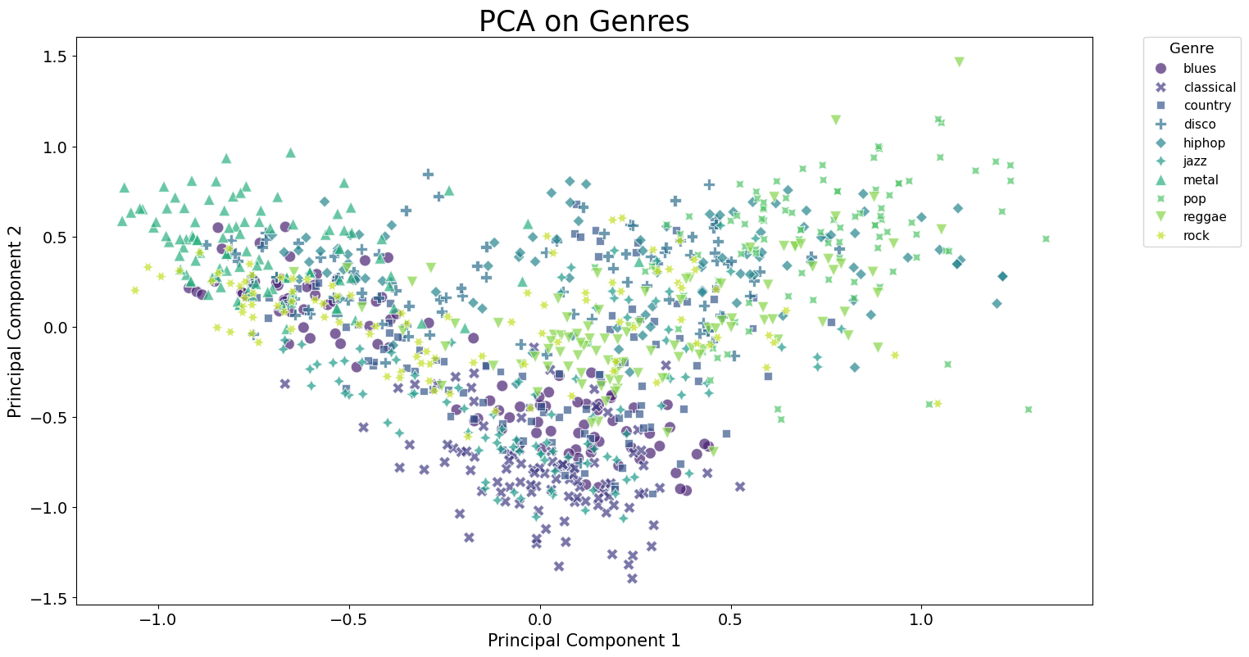

Model Selection and Evaluation

* Models Evaluated: We evaluated several machine learning models, including K-Nearest Neighbors (KNN), XGBoost, and Random Forest.
  + K-Nearest Neighbors (KNN): KNN achieved the highest accuracy, significantly outperforming other models. Hyperparameter tuning identified the optimal configuration with a 'manhattan' metric, 3 neighbors, and 'distance' weighting, achieving a test accuracy of 92% and training accuracy of 94%.
  + XGBoost: Conducted an extensive grid search to optimize hyperparameters, achieving a test accuracy of 90.79%. XGBoost performed well but showed lower precision and recall for certain classes due to overlapping features.
  + Random Forest: Demonstrated strong performance in handling complex patterns but was slightly less effective than KNN and XGBoost.
* Performance Analysis: Evaluated models based on precision, recall, and F1-scores, with KNN showing high precision and recall across all classes, indicating balanced prediction capability.

Recommendation System

* Development: We developed a recommendation system using cosine similarity to match songs based on extracted audio features. This involved analyzing features such as pitch, tempo, and timbre, representing them as vectors, and using cosine similarity to find and recommend audio files most like a given query.
* Output: The system provided ranked lists of recommended songs for given query tracks, enhancing the music discovery experience by efficiently matching songs with similar audio characteristics.

Key Findings and Conclusions

1. Model Performance: K-Nearest Neighbors (KNN) emerged as the best-performing model for genre classification, demonstrating robust accuracy and balanced precision-recall across all classes. XGBoost also showed strong performance but struggled with certain classes due to feature overlaps.
2. Feature Importance: Perceptual variability, spectral bandwidth, chroma features, MFCCs, and spectral roll off were identified as critical features for genre classification.
3. Recommendation System: The cosine similarity-based recommendation system effectively matched songs with similar audio characteristics, enhancing user experience by providing relevant recommendations.

**Conclusion**

This project successfully harnessed the power of machine learning to delve into the intricate world of music analysis, classification, and recommendation. By leveraging the GTZAN dataset and implementing advanced models like K-Nearest Neighbors and XGBoost, we developed a robust framework for genre classification and a functional recommendation system. These tools enhance the music discovery process, providing users with accurate genre classifications and relevant song recommendations. Moving forward, expanding the model architecture and incorporating real-time deployment and user feedback will further refine and personalize the music recommendation experience.